Experiment no-2
Hotel Booking System
AIM:
To develop an online hotel booking website using HTML, CSS, and JavaScript to search for hotels and check room availability. The system allows users to book, modify, and cancel reservations and view booking history.
Procedure:
- Create a hotel booking form using HTML.
- Apply CSS for page styling.
- Use JavaScript to validate booking details.
- Display room availability and booking confirmation.
- Test the website in a browser.
Sample Code:
<!DOCTYPE html>
<html>
<body>
<h2>Hotel Room Booking</h2>
<input id="name" placeholder="Customer Name">
<input id="days" type="number" placeholder="Number of days">
<button onclick="book()">Book Room</button>
<p id="result"></p>
<script>
function book() {
let name = document.getElementById("name").value;
let days = Number(document.getElementById("days").value);
if (name && days > 0) {
document.getElementById("result").innerHTML =
"Room booked for " + name + " for " + days + " days.";
} else {
document.getElementById("result").innerHTML =
"Enter valid details";
}
}
</script>
</body>
</html>
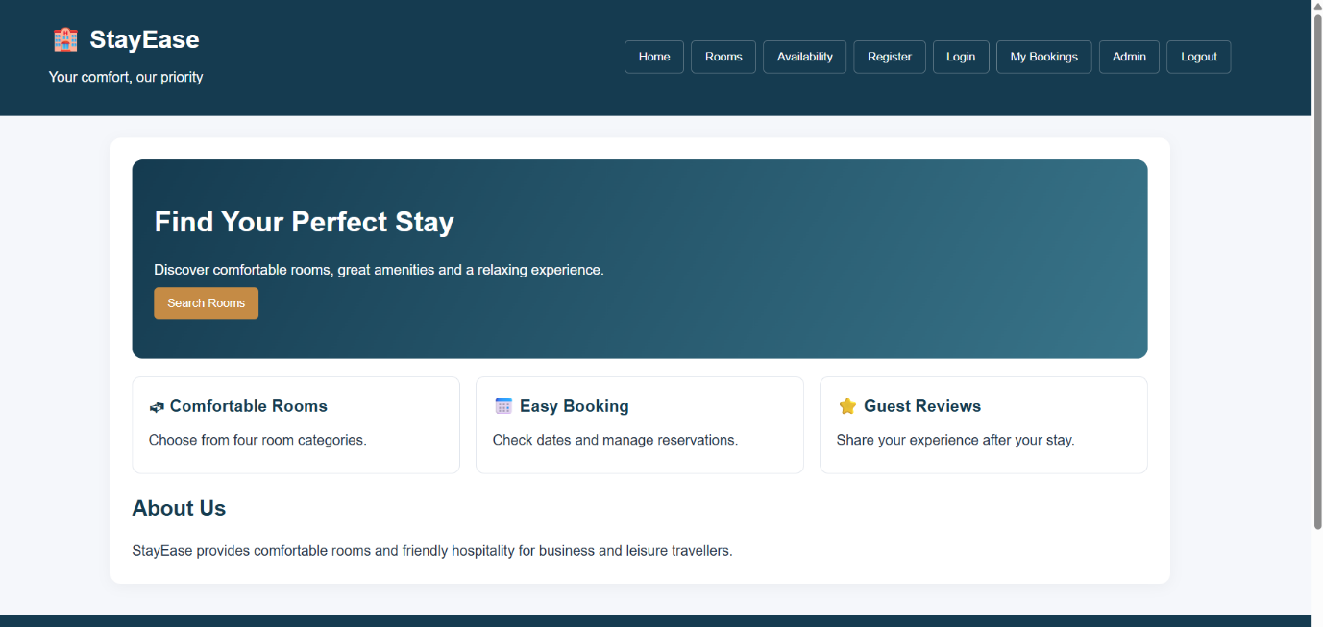
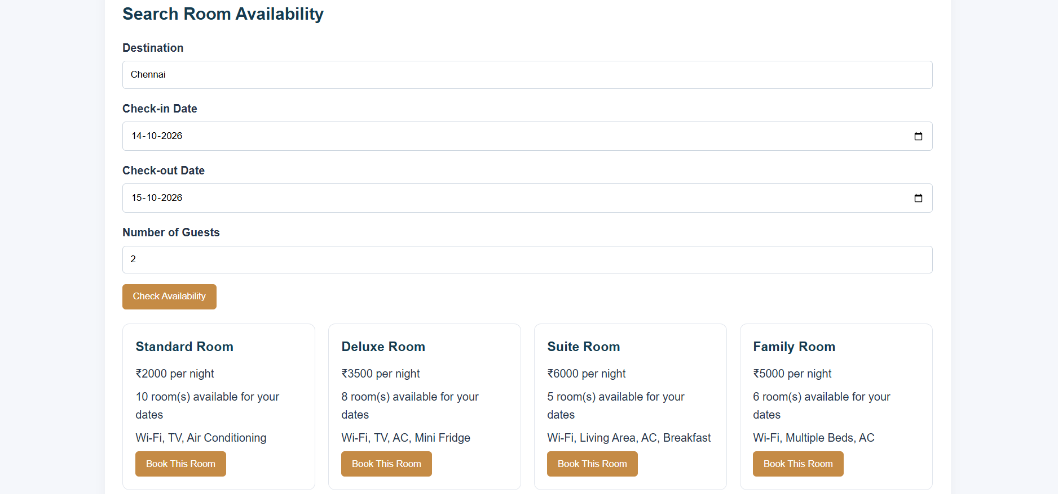
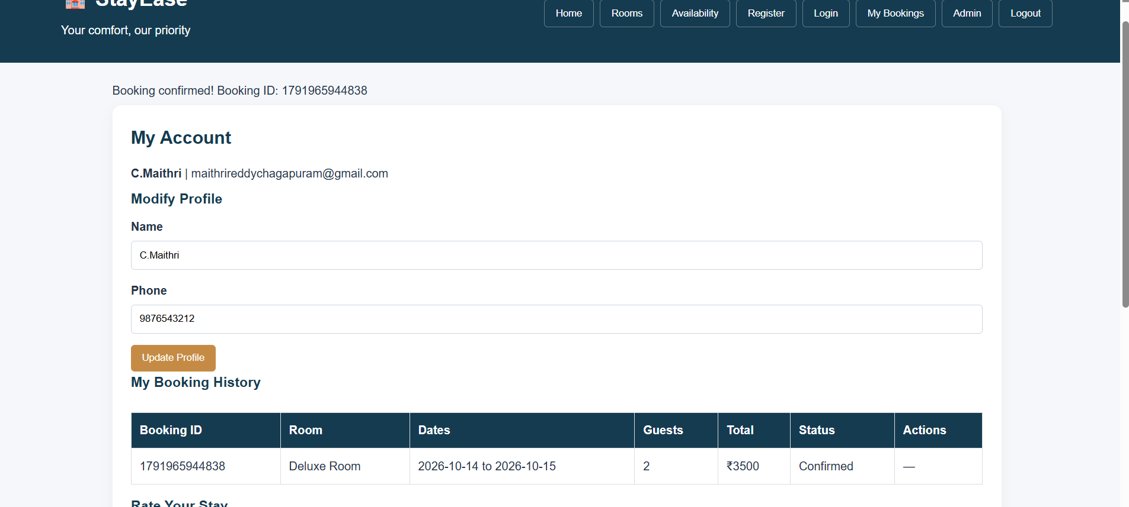
Result:
The hotel booking website was developed successfully to check room availability, book rooms, manage reservations, and view booking history.

